

Goat fell Access Paths Report
28/11/2025

Background
Goat Fell, at 874m high, is the highest mountain on the Isle of Arran. With magnificent views, the summit is the most popular mountain walk for visitors and locals. The walk up Goat fell takes people into the wild and rugged mountain environment typical of the Highlands of Scotland, and yet it is only 2 hrs from Glasgow and the main conurbations of Scotland.
Visitor counter figures show 20,400 people use the main Goat fell path and a further 11,200 people use the Corrie path (figures based on three-year average). With the Isle of Arran now designated as an UNESCO Geopark and with new ferries on the horizon, it is expected that the pressure on the mountain will increase.
The National Trust for Scotland own the higher sections of both paths and have an ongoing repair and maintenance programme that keeps the mountain paths in good condition. However, the lower sections of each route are under different ownership and have degraded due to the volume of walkers and the level of rainfall. In recent years the rainfall events have intensified with large volumes falling in short times causing erosion of the paths. This left sections of the path surface aa a jumble of rocks with widening erosion line with water running straight down the path causing more erosion.
Aim
This project aimed to repair the lower sections of the Goat fell and Corrie paths to address the poor path condition, manage water flows on the path to reduce erosion in the future and build a robust path surface to increase the carrying capacity of the path while protecting the surrounding environment.
Requirements
Repairs consisted of construction of stone cross drains, water bars and associated ditches to control water flows, stone pitching where required and landscaping to keep walkers to the repaired path and reduce erosion and creation of braid lines.

To undertake these repairs extra stone was airlifted onto the site so that stone was available where it was required, making best use of skilled footpath workers and reducing the impact of transporting materials along the repaired paths.
91 bags of stone and aggregate were flown onto the Goat fell path and 20 onto the Corrie path.
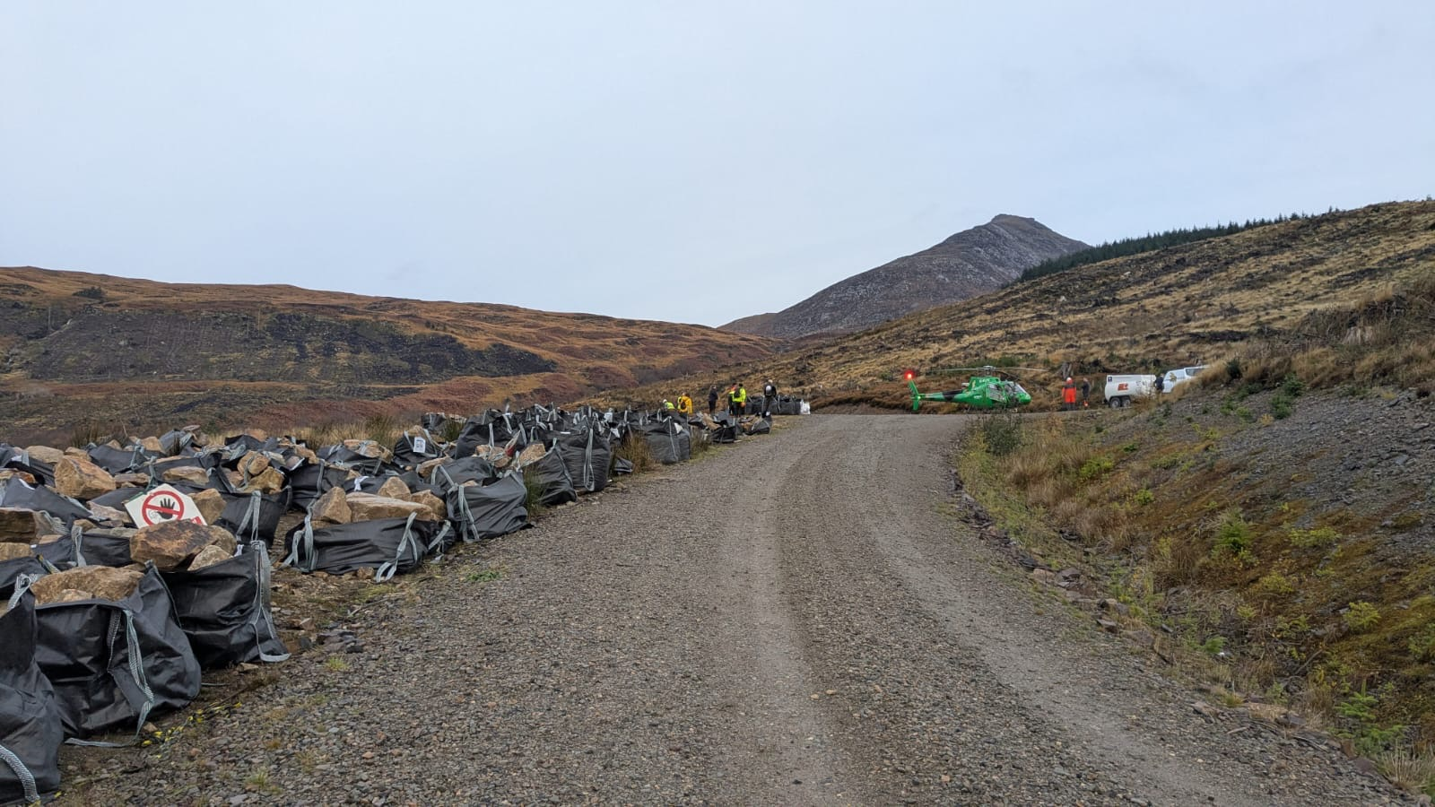
Below: Stone and aggregate ready to be helicoptered onto the paths for repairs to start.

In total 95 tonnes of stone and 40 tonnes of aggregate were flown onto the paths for the repairs (87 tonnes of stone and 30 tonnes aggregate onto the Goat fell path and 8 tonnes stone and 10 tonnes aggregate onto the Corrie path).

Below: Helicopter lifts tonne bags of stone onto the Goat fell path.
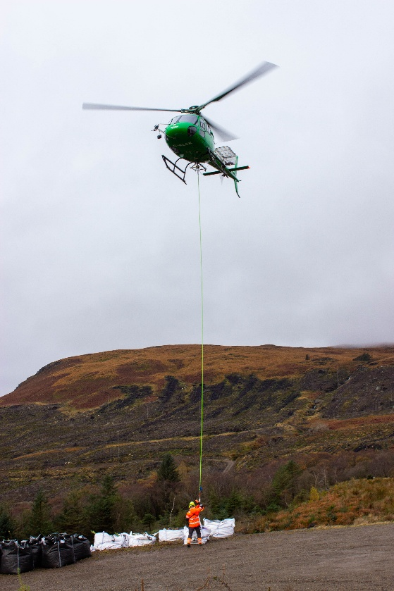
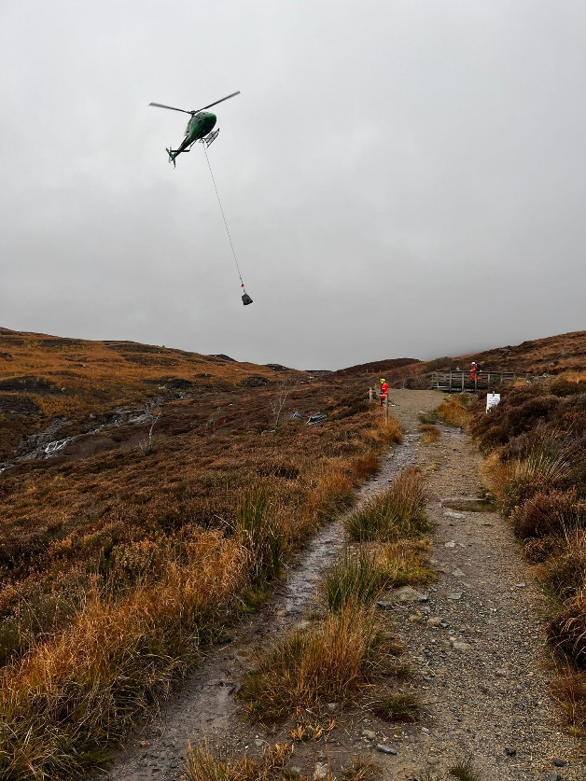

Once the stone was on site, repairs could get underway.
The contractors undertaking the repairs were skilled footpath workers with experience of repairing upland paths on Arran and throughout Scotland.
The paths now have a robust walking surface meaning that walkers will stay on the path rather than creating new braid lines, reducing the erosion in the area. The paths are now future proofed for further climate change and increase in footfall with more water features to remove water from the path surface and take water across the paths.
Completed
680m path repairs on the Goat fell main path including 110m pitching, 65m aggregate path, 10 water bars, 30 anchor bars,15 cross drains, 50m² blocking, 25m revetment, and 75m ditching.
116m path repairs on the Corrie path including 10m pitching, 30m aggregate path, 5 anchor bars, 5 cross drains, 3 water bars and 15m ditching.

Before and after photos

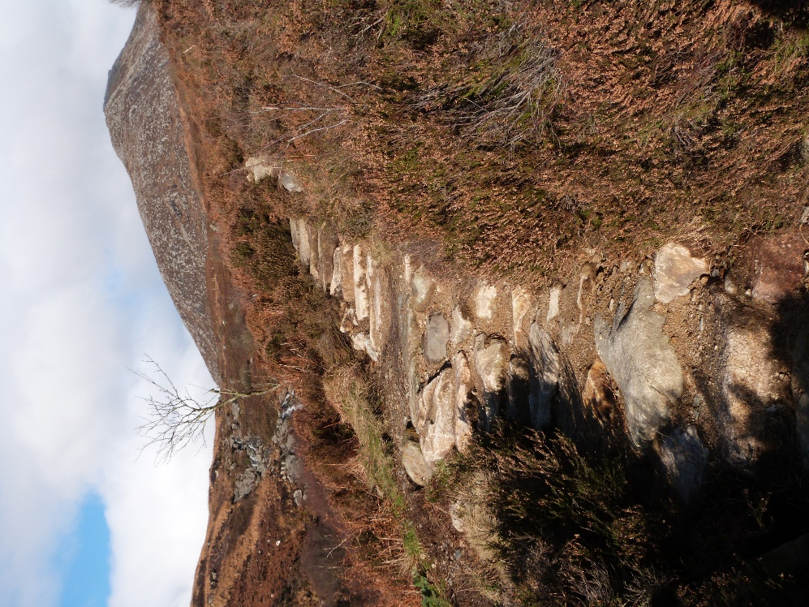
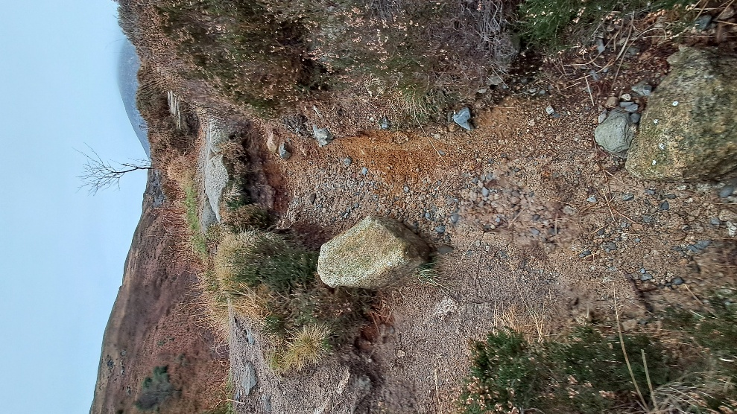

Before there were deep eroded gullies that trapped water and caused further erosion. These have been filled in with pitched stone surfaces and protective water bars above to take water off the path.

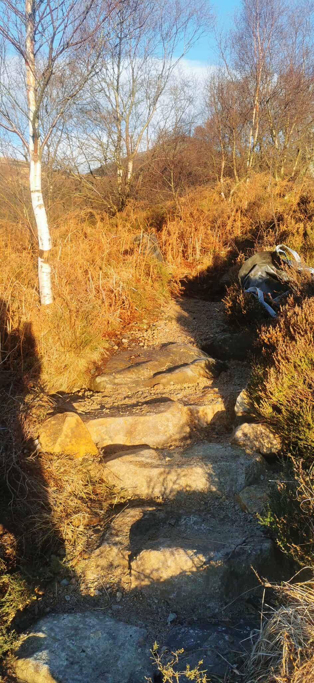
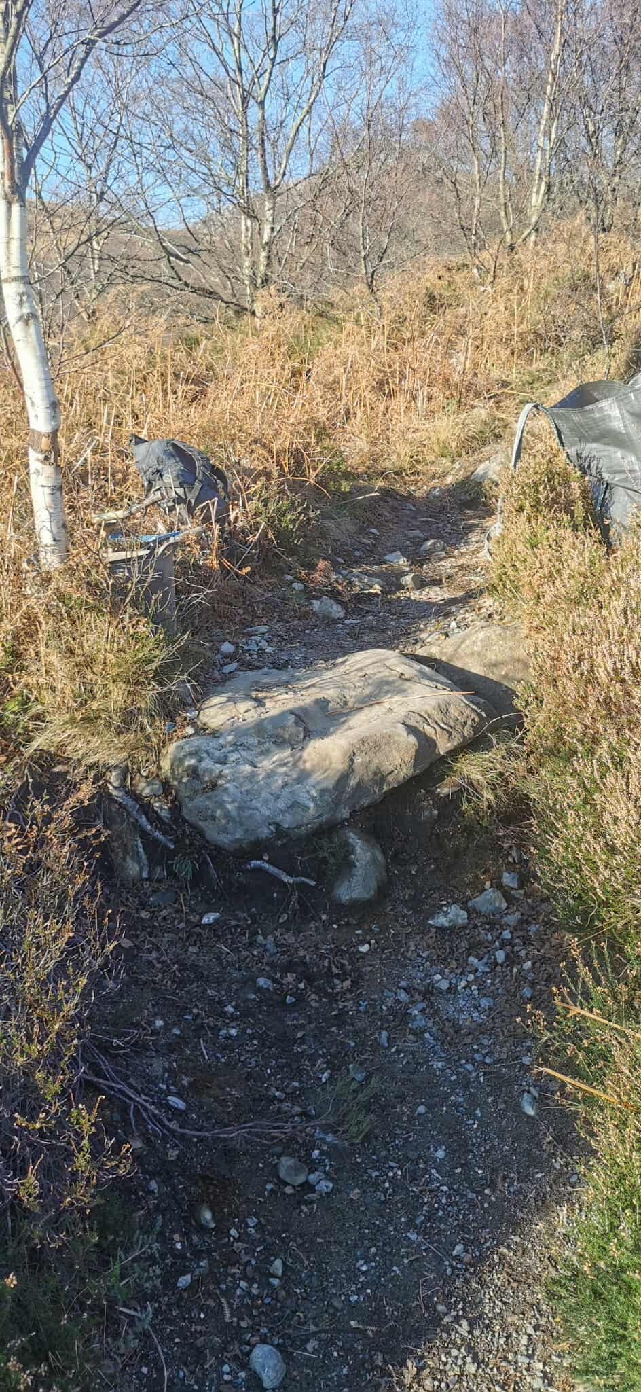

Before there were places with large drops where the path surface had washed away. These have been repaired using short sections of pitching, providing a better walking surface for walkers, but also reducing the erosion of the path.

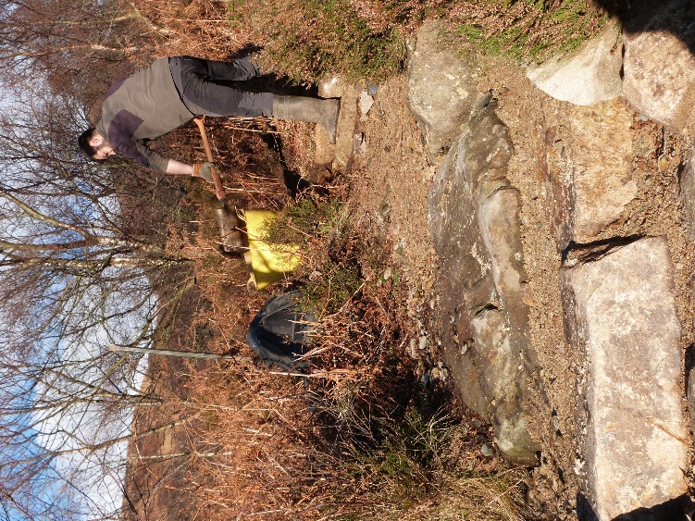
Footpath worker using aggregate to surface the path.

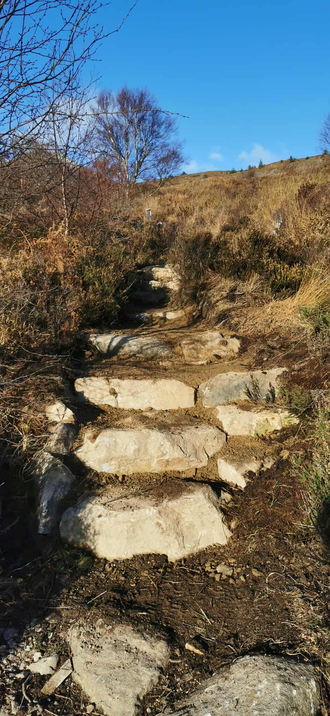
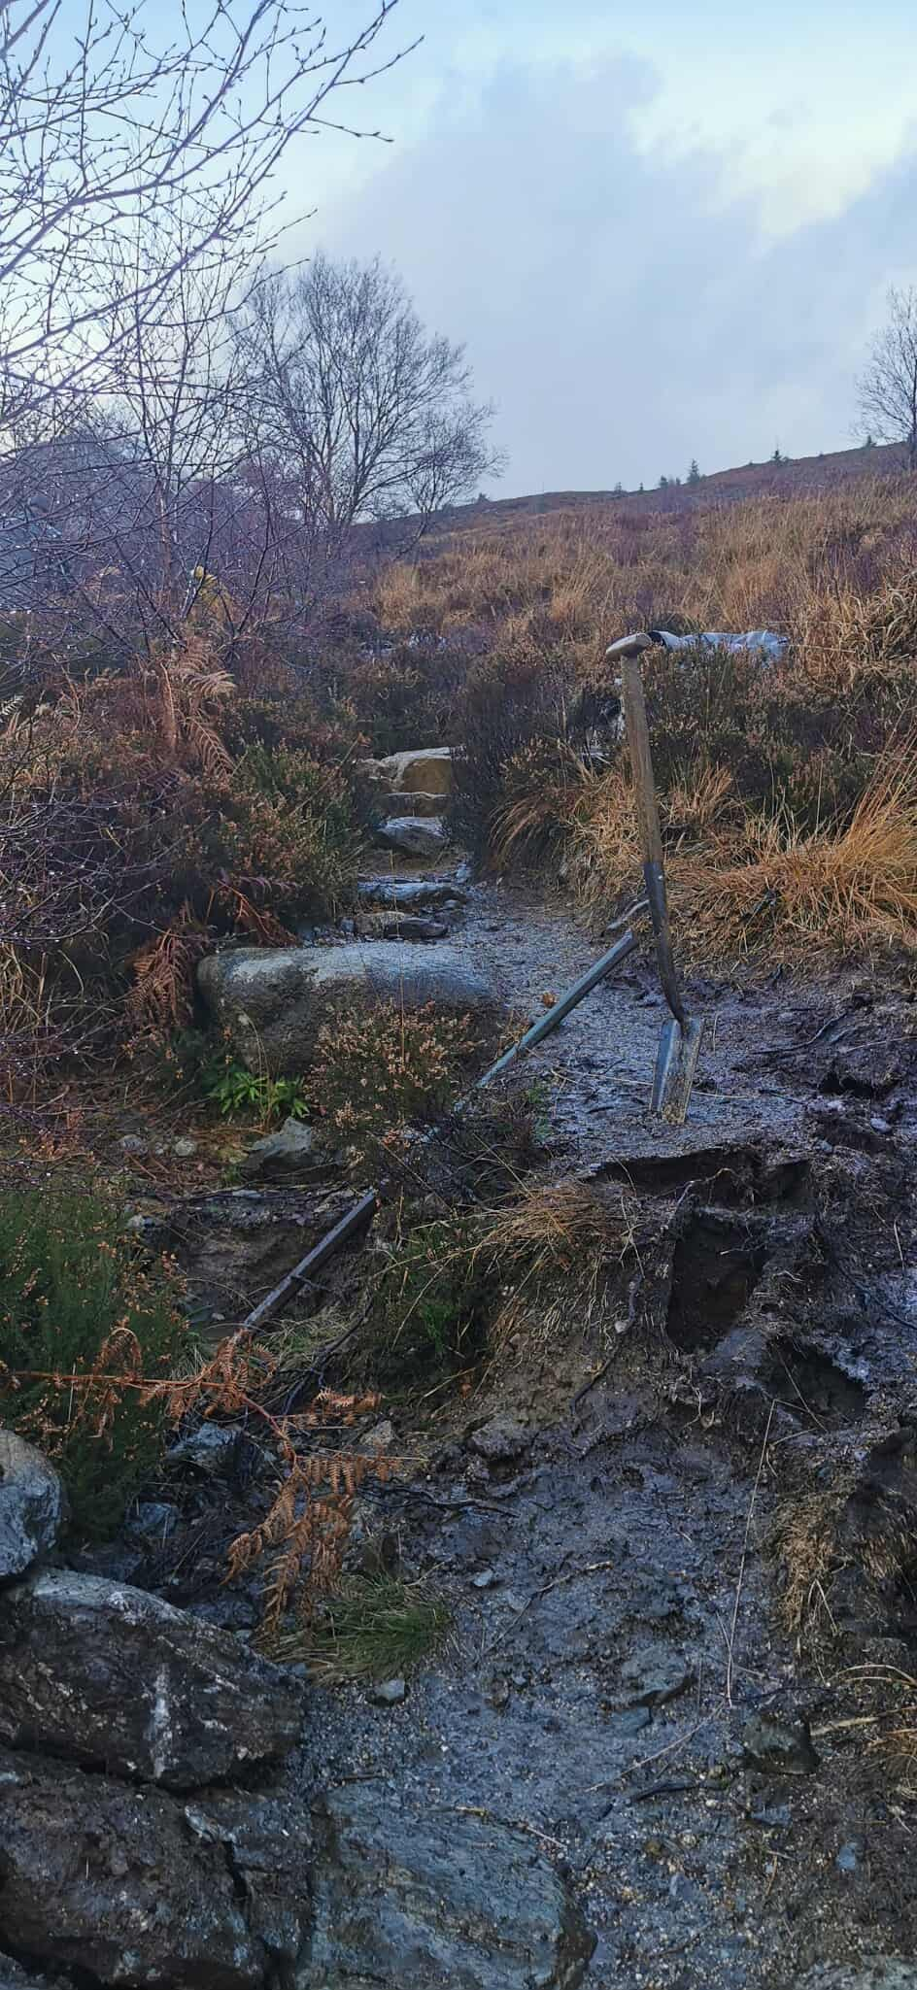

A mixture of aggregate and stone surfaces has provided a better walking surface for walkers that will be more robust for increased footfall.

